Use of Force by MPD

By Samantha Kearney

# Introduction

This is a study of where the Milwaukee Police Department’s use of force incidents occurred in the first three quarters of 2020 (the most recent of this data type available). This information is of interest to community groups and aldermen because more equitable policing is desired. The Black Lives Matter movement and other recent events have enhanced people’s desire to better understand the interactions between police and the communities they serve. Evaluating the data published by MPD about use of force incidents can help enlighten policymakers, activists, and the general public.

# Data

The Milwaukee Police Department publishes quarterly data to the Milwaukee Data Portal. The data is split into many tables, perhaps because the relational database used by MPD functions by storing information in many separate tables, so when the data is exported, the data they upload to the Milwaukee Data Portal must be recombined with other tables to provide meaningful context.

For example, the location of all police cases are stored in a separate table than many other details. Similarly, the table that lists all uses of force by the police department does not list many other case details. Furthermore, the keys in these tables do not always have matching names, so it takes time to review the data to find which key in one table matches a key in another- and those data types may not match- one might be an integer, and another a float (or decimal) number.

Since data is uploaded every quarter, sometimes the headers or columns of data changed from one quarter to another. In total, fifteen separate MPD tables were used from the Milwaukee Data Portal.

# Methodology

In order to use MPD’s data, it was necessary to clean the data so that column formats and header names were uniform across keys so that tables could be merged and joined.

Once this was accomplished, it became possible to map the data (which previously had no latitude and longitude associated with each use of force). With a latitude and longitude linked to each unique instance of a police case involving a use of force, points were plotted on a map of Milwaukee using Folium.

Folium also has a heatmap component, which is a great tool for visualizing locations which had the most/fewest incidents of MPD’s use of force.

# Results

Here is a map (on the following page) with each incident of the use of force plotted as a point.

Use of Force Incidents reported by MPD, Q1-Q3, 2020

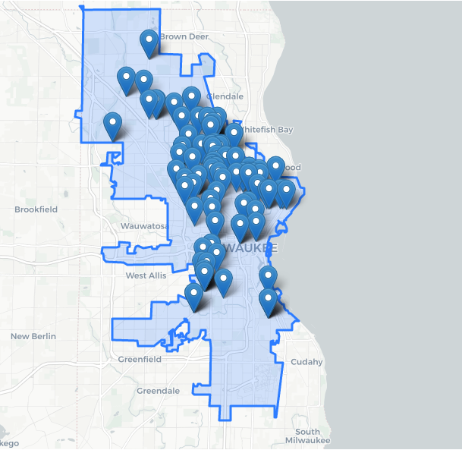

The points are close enough in some areas that they obscure how many incidents occurred. This is why using a heatmap (see following page) to display the data is more effective.

Milwaukee Police Department’s Use of Force Hotspots, Q1-Q3, 2020

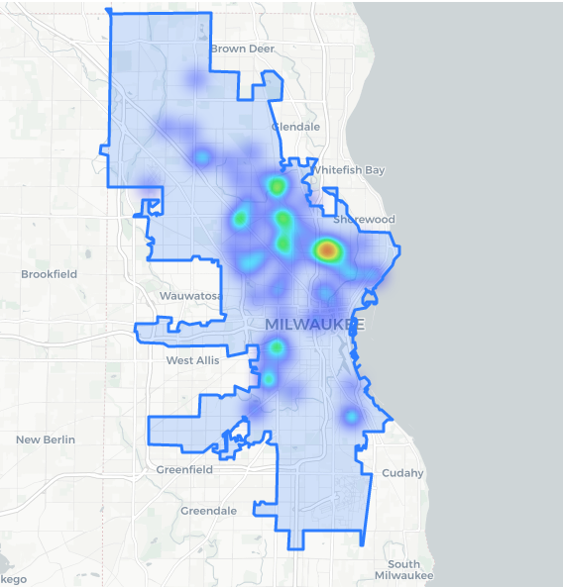

# Discussion

The use of force maps show that more incidents occur on Milwaukee’s north side, and to a lesser extent, in Central Milwaukee. I was unable to link the incidents of MPD’s use of force with geographic areas such a census tracts in order to directly analyze the correlation between MPD’s use of force with demographic data, but comparing the heatmap to other maps that show demographic data is still illuminating. The maps below, from Statistical Atlas, show demographic data from the 2010 census, specifically the density of white, Black, and Hispanic residents in the city. By comparing the heatmap and these demographic maps, it is clear that the areas where MPD’s use of force occurs most frequently tend to be in communities of color.

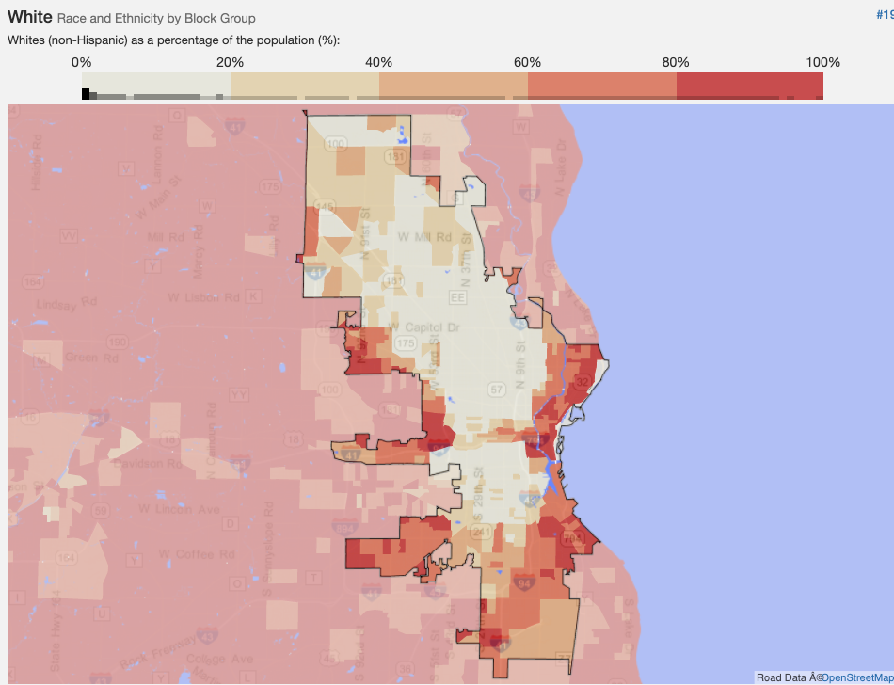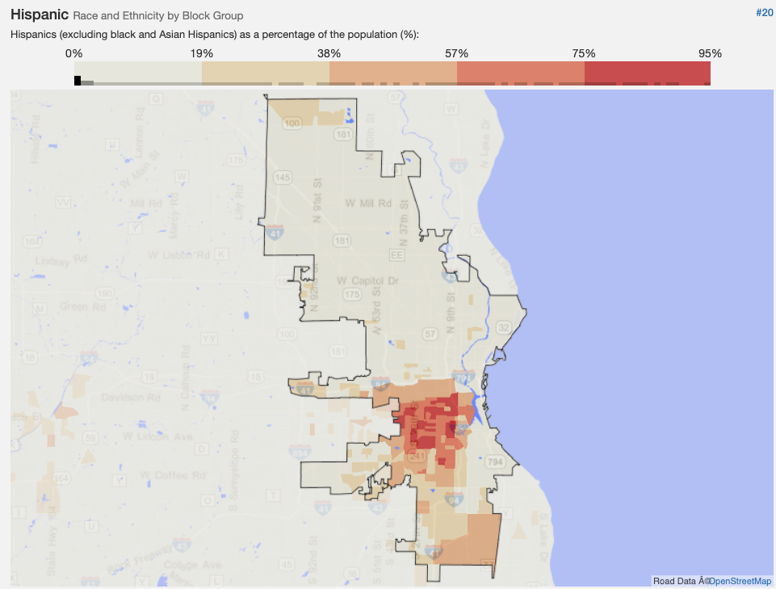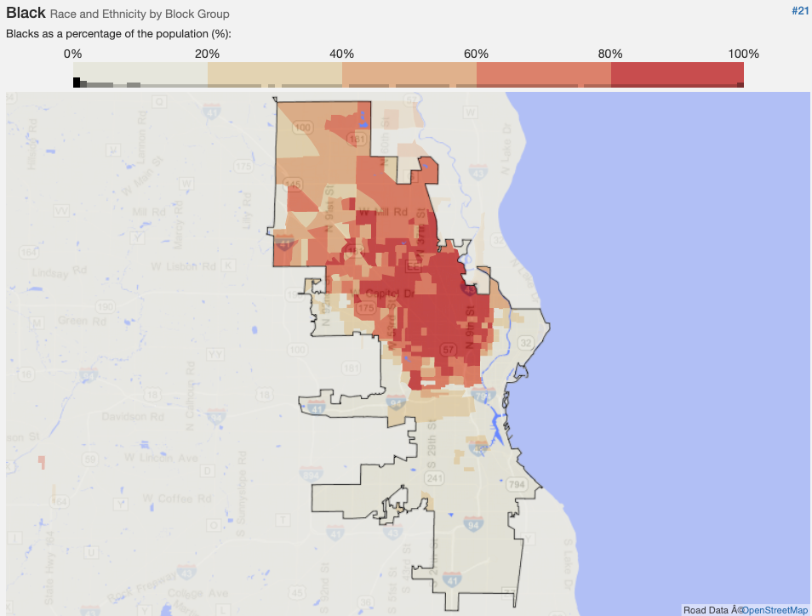

# Conclusion

Comparing the heatmap to demographic maps does show that the Milwaukee Police Department’s (MPD) use of force in the first three quarters of 2020 tend to occur in communities of color. To better understand the correlation and other nuances, a longitudinal study comprising of several years’ of data, as well as finding a way to include demographics of those whom force was used against, and/or finding a way to merge/dissolve these data points into census tract polygons (as one can do using mapping software such a Esri’s ArcGIS Pro or QGIS) using Python and Folium would be helpful. It is possible to make choropleth maps in Folium, but only if the table with each record you want to count (in this case the use of force) also has a column stating which polygon it belongs in (such as census tract). Finding a method to link points with polygons would open up a world of statistical analysis possibilities. Still, the spatial analysis that Folium’s heatmap provides clearly shows the hotspots for MPD’s use of force, and those hotspots are primarily in communities of color.